Announcement

20th PRCP Congress in Kuala Lumpur on 13-15 October 2023
‘Building Mental Health Resilience Across the Lifespan’

The theme of the PRCP 2023 congress is ‘Building Mental Health Resilience Across the
Lifespan.’ The main objectives of the PRCP Congress are to enhance continuing medical
education. The scientific committee has selected a wide range of topics participants can
choose to present, sharing their know-how with their colleagues across the pacific rim.
Moreover, the conference will be about mental health professionals sharing ideas about their
experience helping the community work to restore stability while strengthening one’s
resilience.

During the three days, world-class invited eminent speakers will share their expertise. These
eminent speakers will add value to the conference providing delegates with up-to-date
knowledge in their field of expertise.

Kuala Lumpur, in short, KL, is a vibrant capital city of Malaysia. Since its humble beginning
in the 1800s, the city has undergone tremendous development since its discovery. The city
of almost 2 million people has a good infrastructure and offers everything from modern to
ancient sites and food! Kuala Lumpur is a city with a mixture of many cultures, typical of the
diversity of Malaysia. The various tasty cuisines will undoubtedly be the best reason to visit
Kuala Lumpur!

It will be an excellent opportunity for the delegates to attend the conference while exploring
the sights, sounds, and flavors of Kuala Lumpur. So, make a date with us:

PRCP 2023, 13-15 OCTOBER 2023
HILTON KUALA LUMPUR

https://prcp2023.com

Professor Dr Ahmad Hatim Sulaiman
Kuala Lumpur, Malaysia
Organising Chairman,
20th PRCP 2023

Newsletter Contents

- Editor’s introduction
- President’s message
- Secretary General’s message
- Financial report
- Report on Malaysian Psychiatric Association meeting in Kuala Lumpur
- Asia Pacific Psychiatry Journal report
- Report on the education program run by Prof Chee
- Biographical pieces by new PRCP members
- Renew your PRCP membership
10. Application for membership
11. Dates for upcoming PRCP Executive Committee and Board meetings

- Editor’s introduction

Dear PRCP Colleagues, I hope you enjoy our informative PRCP November 2022 Newsletter. This newsletter carries reports from the PRCP President, Secretary-General, Vice-President, and Treasurer. The Newsletter also includes reports from Malaysian Psychiatric Association meeting in KL September 2022 attended by PRCP executive members, the PRCP education program supervised by President Prof Chee Ng, the Asia-Pacific Psychiatry Journal, and information about new PRCP members. This Newsletter contains details about our exciting upcoming 20th PRCP Congress to be held from 13-15 October 2023 in Kuala Lumpur, Malaysia.

The PRCP is a growing organization with new members joining this year. The expertise, knowledge and diversity of experience of these new members is well described in the biographical sketches in the Newsletter. We look forward to the contributions of these new members are grateful for the continuing support of current members.

We are all looking forward to the 20th Congress of the PRCP in October next year in Malaysia. This meeting will be a return to a full face-to-face conference. The Seoul Congress was a great success and will be an inspiration for the organisers of the Kuala Lumpur Congress. We are expecting a very informative meeting and look forward to meeting in-person as many members of our PRCP family as we can.

The theme of ‘Building Mental Health Resilience Across the Lifespan’ is so relevant as we slowly come out from the stresses and challenges of the Covid pandemic. The Congress provides a wonderful opportunity to unite and consider how we as a profession can improve the mental health of the Asia-Pacific region and contribute to the education and development of an excellent mental health workforce for all our countries.

The Asia-Pacific Psychiatry Journal goes from strength to strength and is publishing articles from authors and research teams across the Pacific Rim. It continues to be the ‘Voice of Academic Psychiatry’ for our region.

This newsletter is the informal way members of the PRCP can communicate with each other. In order to make this method of personal connection with colleagues more effective please send short reports or articles on items of interest and photos of yourself and colleagues for publication in the newsletter.

I look forward to your contributions.

Prof Philip Morris AM
Newsletter Editor

- President’s message 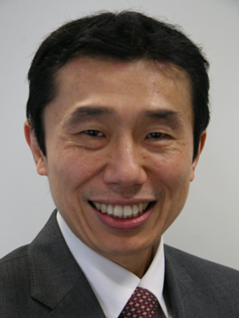

The Pacific Rim College of Psychiatrists

The Pacific Rim College of Psychiatrists (PRCP) is an Association of psychiatrists from countries and territories around the rim of the Pacific Ocean as well as the Asian region (https://www.prcp.org/). Since academic psychiatrists founded it on May 15, 1980, the membership is opened to all psychiatrists working in clinical, administrative, or academic practice. The PRCP aims to foster the development of quality mental health services, and to support the improvement of education and research in psychiatry through greater professional collaboration in the region. The PRCP also organises a biennial conference to provide a formal setting for communication among its membership, which currently consists of about 225 psychiatrists from 15 countries.

In recent years, our world has faced with unrelenting global challenges, including the COVID-19 pandemic, climate change, and countries in conflicts. The mental health burden is rapidly growing for individuals, their families, communities, and public health systems, especially for frontline workers and vulnerable populations. As of 16th August 2022, the WHO reported over 595 million confirmed cases and 6.46 million deaths from COVID-19. The United Nations High Commissioner for Refugees (UNHCR) estimated that there are approximately 90 million people worldwide who were forcibly displaced at the end of 2021 as a result of persecution, conflict, violence, human rights violations or events seriously disturbing public order. These include 27.1 million refugees and 53.2 million internally displaced people globally.
Global emergencies, such as the COVID-19 pandemic, natural disasters, armed conflicts, and others have led to increasing psychological distress and associated disorders such as depression, anxiety, and PTSD. With such devastating mental health effects and psychological trauma, developing evidence-based and cost-effective mental health treatments is a public health priority. Hence, it is imperative that the PRCP continues to foster the development of quality mental health services, and to support the improvement of education and research in psychiatry in the region. Through greater professional collaboration, we need to strive to improve research into causes, prevention, and treatment of psychiatric disorders. We also need to promote mental health via education of healthcare workers, policymakers, and the general population. By maintaining the professional activities of the PRCP and communication between our international memberships, we hope to improve psychiatric education and training in the Asia-Pacific countries.

I am heartened to share with you that PRCP is actively contributing to these objectives in the following ways. Asia Pacific Psychiatry (APPSY), the PRCP official journal published by Wiley/Blackwell, is now in its 14th year of publication. The APPSY's Impact Factor for 2021 is 3.788, which places the journal 64/142 in the Psychiatry (Social Science) category and 84/155 in the Psychiatry category. It is now recognised as one of the leading psychiatric journals in the Asia and Pacific region. We strongly encourage PRCP members to submit research articles and reviews, particularly clinically and educationally focused papers that can translate to current best practices in psychiatry.

International psychiatric academic associations, including the European Psychiatric Association (EPA), American Psychiatric Association (APA) and World Psychiatric Association (WPA), have released statements on how the Ukraine war will exacerbate mental health problems. An inter-organisation paper (including the PRCP) was published in Nature Medicine in May 2022, calling for inter-organizational collaboration to address the mental health crisis as a result of the armed conflict. The paper call for a joint effort, nationally and internationally, to address and minimize the mental health suffering of conflict-affected populations.

Finally, it gives me great pleasure to warmly welcome you all to join us in our biennial 20th PRCP Congress in Kuala Lumpur on 13-15 October 2023. We anticipate that the Congress will deliver an outstanding scientific program to promote academic exchange and professional collaboration in the Asia-Pacific. The theme of the Congress, ‘Building Mental Health Resilience Across the Lifespan’, is both appropriate and pertinent as many countries in our region are dealing with the impact of global challenges with regards to health, conflict, climate and equality issues. I look forward to seeing you at the PRCP Congress in Kuala Lumpur hopefully in person, if not virtually.

Professor Chee Ng MBBS, MD, FRANZCP
Healthscope Chair of Psychiatry, The Melbourne Clinic
Professor of Psychiatry, The University of Melbourne
President PRCP

- Secretary General’s message

Under the tenure of Prof Chee Ng, the Executive Committee and the Board have met regularly, and the secretariat has supported the meetings and follow-ups.

The Executive Committee has met
October 21, 2021
January 27, 2022
April 28, 2022
July 21, 2022
October 6, 2022
The board has met
October 21, 2021
April 28, 2022
October 6, 2022

The principal agenda of these meetings were
The 19th PRCP congress 2021, 8-10 April in Seoul – Report of the great success
The 20th PRCP Congress in 2023, 13-15 Oct in Kuala Lumpur
The 21st PRCP Congress in 2025, in Tokyo
Asia-Pacific Psychiatry Journal
PRCP website
The APRE-Training
Collaboration with the 22nd WPA World Congress of Psychiatry in Bangkok, 3-6 August 2022
Publication in Nature Medicine
Collaboration with AFPA

Please get in touch with the secretariat if the PRCP members have any input about the agenda or other issues.

In July 2022, the secretariat staff changed from Ms. Maria Oceja to Ms. Toshiko Hano. I thank Maria for her excellent job for the PRCP and sincerely appreciate Toshiko for her most efficient work for the secretariat.

Tsuyoshi Akiyama

- Financial report

Dear PRCP Colleagues, we currently have a generally healthy financial situation for the PRCP. We have a small increase in income this year offset by slightly higher expenses. Overall, at year end, we expect to be about USD$1000 better off than budgeted (ie. a deficit of USD$12,234 compared with the expected budget deficit of USD$13,511). Our total equity remains substantial at USD$122,058.
Yours sincerely, Philip Morris AM (Treasurer).

- The PRCP Pre-Congress Workshop at the Malaysian Conference of Psychological Medicine

The 26th Malaysian Conference of Psychological Medicine (MCPM) was held on 9th – 11th September 2022 at Sheraton Imperial Kuala Lumpur. The theme of the conference was “Embracing Diversity, Empowering Community”. On the invitation of Prof Ahmad Hatim Sulaiman, a PRCP Pre-Congress Workshop was organised to promote the PRCP Congress 2023 in Kuala Lumpur. In this Pre-Congress Workshop, Prof Chong Mian Yoon spoke on “Mindset Matters! Inspiring The Young Mental Health Professionals to be Significant in the Current Reality”, while Prof Chee Ng presented on “Paradigm Shift for A Healthy Workplace Culture and Better Workplace Mental Health”. Both workshops were attended by over 50 participants and were well received. The following day at the main conference, Prof Chee Ng also delivered a keynote address on “Empowering and Building Capacity of Telepsychiatry”. A planning meeting for the PRCP Congress 2023 was also held with Prof Ahmad Hatim Sulaiman and the Local Organizing Committee on the 9th September 2022.

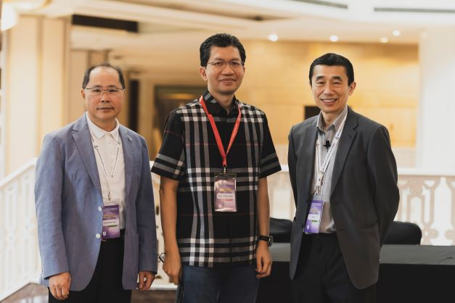

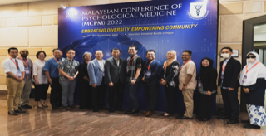

6. Asia Pacific Psychiatry Journal report

Dear Colleagues,

It is once again a pleasure to contact you with my brief update about the progress of our journal, Asia Pacific Psychiatry. We have had another very good year for which I am extremely appreciative. Our two new Editors, Takahiro Kato and Alan Teo, have been carrying out their responsibilities in an exemplary manner and it is a pleasure to have them well integrated into our journal editorial review process. Of course, Helen Chiu and Yu Tao Xiang, our Associate Editors, and Chee Ng, our Deputy Editor in Chief remain steadfast in their commitment to excellence for APPSY and remain extremely valuable and outstanding leaders of APPSY. Our staff at Wiley are exceptionally supportive of our journal which produces outstanding collaboration.

The ongoing problems related to the COVID pandemic have created difficulties for a number of journals around the world, but fortunately not for APPSY. For example, an extremely well regarded international journal which publishes monthly received only about twice the submissions as APPSY did last year. In contrast, in 2021 we received nearly 450 submissions, continuing an ongoing increase over the last number of years. Our acceptance rate is less than 15%, reflecting an extremely competitive environment and higher quality for the journal. As an illustration, our impact factor continued to improve from 2.538 in 2020 to 3.788 in 2021 marking the largest single year increase in our history. While we ranked in the bottom quartile when I became editor in chief, we now rank 64 out of 142 journals in the Psychiatry (social science) listing and near the midrange of 155 journals in the Psychiatry listing.

The progress we have made would not have been possible without the ongoing support of PRCP, and we look forward to many productive years ahead.

With thanks and best wishes for a safe, healthy, and satisfying new year in a world of peace,

Allan Tasman, MD
Editor in Chief

- Asia Pacific Regional E-Training (APRE) 2021 Report – Chee Ng

The Asia Pacific Regional E-Training (APRE) was developed in 2021 to build digital mental health capacity for mental health professionals in low and middle-income Asia-Pacific countries. This project was made possible by the generous support from the PRCP Seoul Congress. The program used a mixed model of training to focus on practical support for young psychiatrists and mental health workers, with peer exchange offering opportunities for engagement, information and resource sharing. The program structure focused on learning via online teaching, reflective practices, and peer exchanges, with the opportunity to integrate training and clinical models. The program also recognised the importance of the multidisciplinary workforce, and how to network with community and health care stakeholders.

Supported by the Pacific Rim College of Psychiatrists, and St. Vincent’s Hospital, Melbourne in collaboration with the Department of Mental Health and Substance Abuse of Ministry of Health, Cambodia, a 10-week online course, with international speakers, information, resources and opportunity was delivered to explore clinical practice, focusing on using digital health tools to provide mental health care. Its objectives were to review global guidance for digital mental health, share experiences from Cambodia, Australia and Asia, and pilot a structure of online sessions that would best suit the international collaboration

A total of 10 sessions were held between October 14 and December 16. There were 63 registrations and over 40 multi-disciplinary participants, 10 speakers, plus 5 observers participated in the sessions. Attendance varied from 47-24 people in each session, with an average of 31 people over the 10 weeks. Each week, the link to the recording and additional materials were sent to the group by the emails. Anonymous zoom poll was carried out, and the responses were reasonably positive. Comments from the final reflection session were shared as well. Internet connections remained a major challenge for the delivery of digital mental health services. As for future suggestions, longer sessions and a telehealth platform were suggested. As the training was considered a success, the PRCP Executive Committee decided to extend the project for a second year in 2022 and will evaluate the project after the 2-year program.

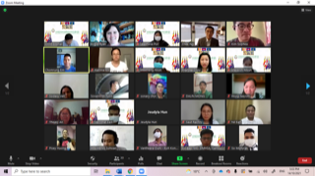

- Biographical pieces by new PRCP members

Dr. John Warlow
MBChB, FRANZCP
Adult, Child and Family Psychiatrist
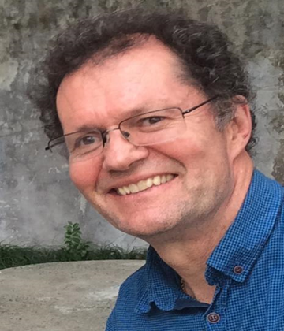

It is a privilege for me to join the PRCP as a Distinguished Fellow, having been invited by Prof Philip Morris, a senior colleague of mine within Queensland, Australia. The main reason I am joining the College is related to my last 15 years of experience of community mental health training in Asia. In this regard, I am the founder of an organisation, which focuses on wholistic well-being, called Living Wholeness. (https://www.livingwholeness.org/about/ ). We are currently involved in approximately 13 different countries in Asia, including those of the Asian aspect of the Pacific Rim. We are a registered not-for-profit organisation in Australia with a board, executive, community leadership and up to about 100 volunteers. We particularly upskill the Christian based communities to serve in their various countries.
In this context, I’m looking forward to becoming a part of a professional community. In particular, I am grateful for this opportunity in terms of the collegiality in advancing the role of psychiatry within the Pacific Rim countries in the context of mutual collaboration and in particular in the area of mental health education to the community.
I myself have been practicing as an Adult, Child and Family Psychiatrist, since 1990. For 10 years I directed the training in Child and Adolescent Psychiatry for the Royal Australian & New Zealand College of Psychiatrists, Queensland. I come from a fairly cosmopolitan background, having been born in India, receiving my medical degree from Birmingham England, and having specialised in Psychiatry in New Zealand. I completed Child and Adolescent Psychiatry in Brisbane, Australia, where I now live, with my wife, five children and seven grandchildren!

- Renew your PRCP membership through our website

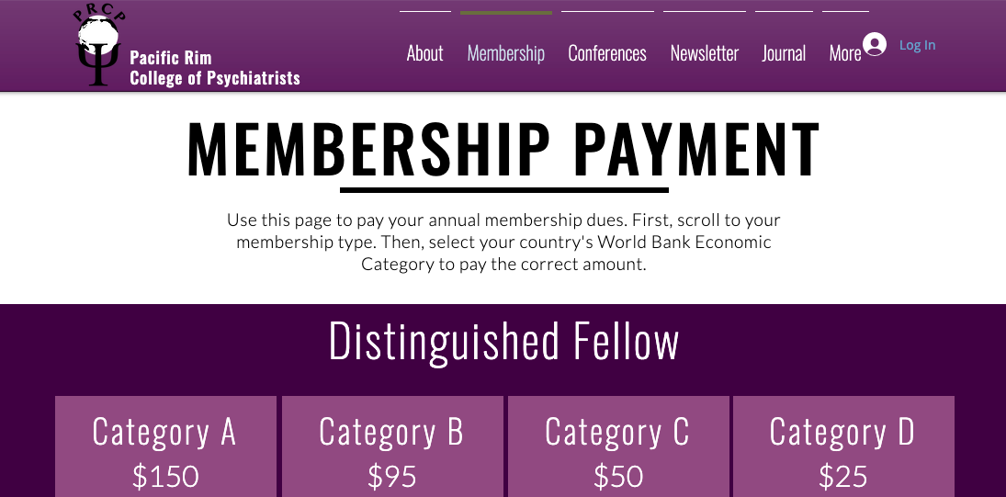

Have you received your membership renewal reminder but not responded yet? Or do you have a colleague interested in joining PRCP?

You can quickly and easily use the updated PRCP website to help.
All you need is to have a PayPal (https://www.paypal.com/) account for electronic payment, and to visit our membership page (https://www.prcp.org/membership-payment). Once there, find your category of membership (Distinguished Fellow, Fellow, or Member). If you are renewing your membership, this information is provided in your reminder email. If you are unsure, email us at info@prcp.org. Then, determine which World Bank economic category your country of residence falls into. If you are unsure, that information is listed here (https://www.prcp.org/world-bank-economic-categories). Click on the “Buy Now” icon that matches your category, and complete your payment. That’s all.

Thank you for being part of the PRCP family!

- Application for membership

APPLICATION FORM FOR MEMBERSHIP OF
THE PACIFIC RIM COLLEGE OF PSYCHIATRISTS
DATE
TITLE
FIRST NAME
LAST NAME
DATE OF BIRTH
COUNTRY: GENDER:
CURRENT POSITION
MAILING ADDRESS
HOME PHONE : FAX:
OFFICE PHONE
E-MAIL
SPECIALIST BOARD: DATE RECEIVED:
􀂉 PSYCHIATRY
􀂉 NEUROLOGY
􀂉 OTHER (PLEASE SPECIFY)
CURRENT INTERESTS:
􀂉 CLINICAL
􀂉 TEACHING
􀂉 RESEARCH
􀂉 CROSS CULTURAL
SPECIALIST TRAINING:
QUALIFICATIONS:
YEARS WORKED AS PSYCHIATRISTS:
MEMBERSHIP OF NATIONAL ASSOCIATIONS:
INTERNATIONAL ACTIVITIES
Please return this form with your CV and one passport photo to the PRCP Secretariat located at:
Department of Neuropsychiatry, NTT MEDICAL CENTER TOKYO
5-9-22 Higashi-gotanda, Shinagawa-ku, Tokyo 141-8625, JAPAN
Phone: + 81 3 3448 6508 Facsimile: + 81 3 3448 6507
E mail: info@prcp.org cc: hano.toshiko2022@gmail.com
*PRCP recognizes World Bank Economic Categories. Please see the PRCP website for details: www.prcp.org/members.html

- Dates for upcoming PRCP Executive Committee and Board meetings in 2023
January: EC meeting date: January 12, 2023
April: EC/Board meeting - proposed dates: April 6, 13, 20 (TBD)
July: EC meeting only - proposed dates: July 6, 13, 20, 27 (TBD)
October: EC /Board meeting: Possible to arrange a face-to-face/hybrid style meeting during the Malaysian Congress, October 13-15, (TBD)

