PRCP Newsletter Summer 2021

Newsletter Contents

Headline Announcement

The 2021 Seoul PRCP Congress was successfully held in Seoul in April 2021 as a hybrid and onsite meeting with 834 registrants, 8 lectures, 40 sessions and over 200 presentations.

1. Newsletter editor’s report - Philip Morris
2. President’s report – Chee Ng
3. President Elect’s report - Yong Chon Park
4. Vice President’s report- Tao Li, Edmond Pi
5. Treasurer’s report - Philip Morris
6. Secretary General’s report - Tsuyoshi Akiyama
7. Asia-Pacific Psychiatry editor report – Allan Tasman
8. PRCP Website – Alan Teo
9. Messages from our new board members
9.-1 – Chonnakarn Jatchavala (Thailand)
9.-2 – John Wong Chee Meng (Singapore)
9.-3 – Takahiro Kato (Japan)
9.-4 – Ahmad Hatim bin Sulaiman (Malaysia)
9.-5 – Huali Wang (China)
10. List of PRCP Office Bearers and Board Directors
11. Application for membership
You can see the latest newsletter Summer 2021 on our website.
https://www.prcp.org/newsletter

The 19th PRCP Congress: PRCP 2021 Seoul

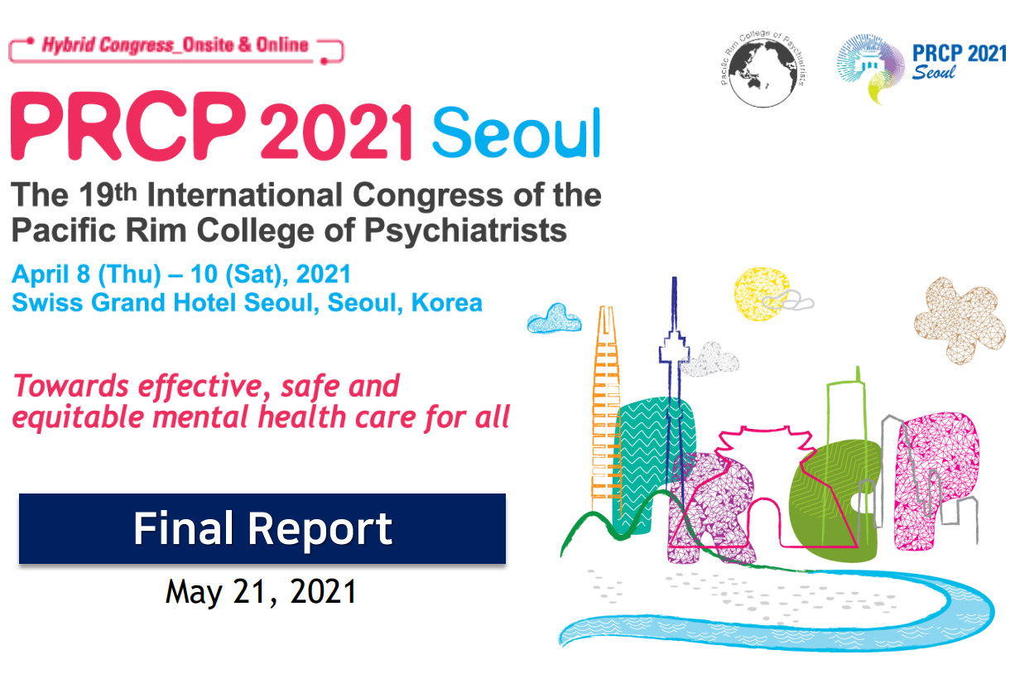

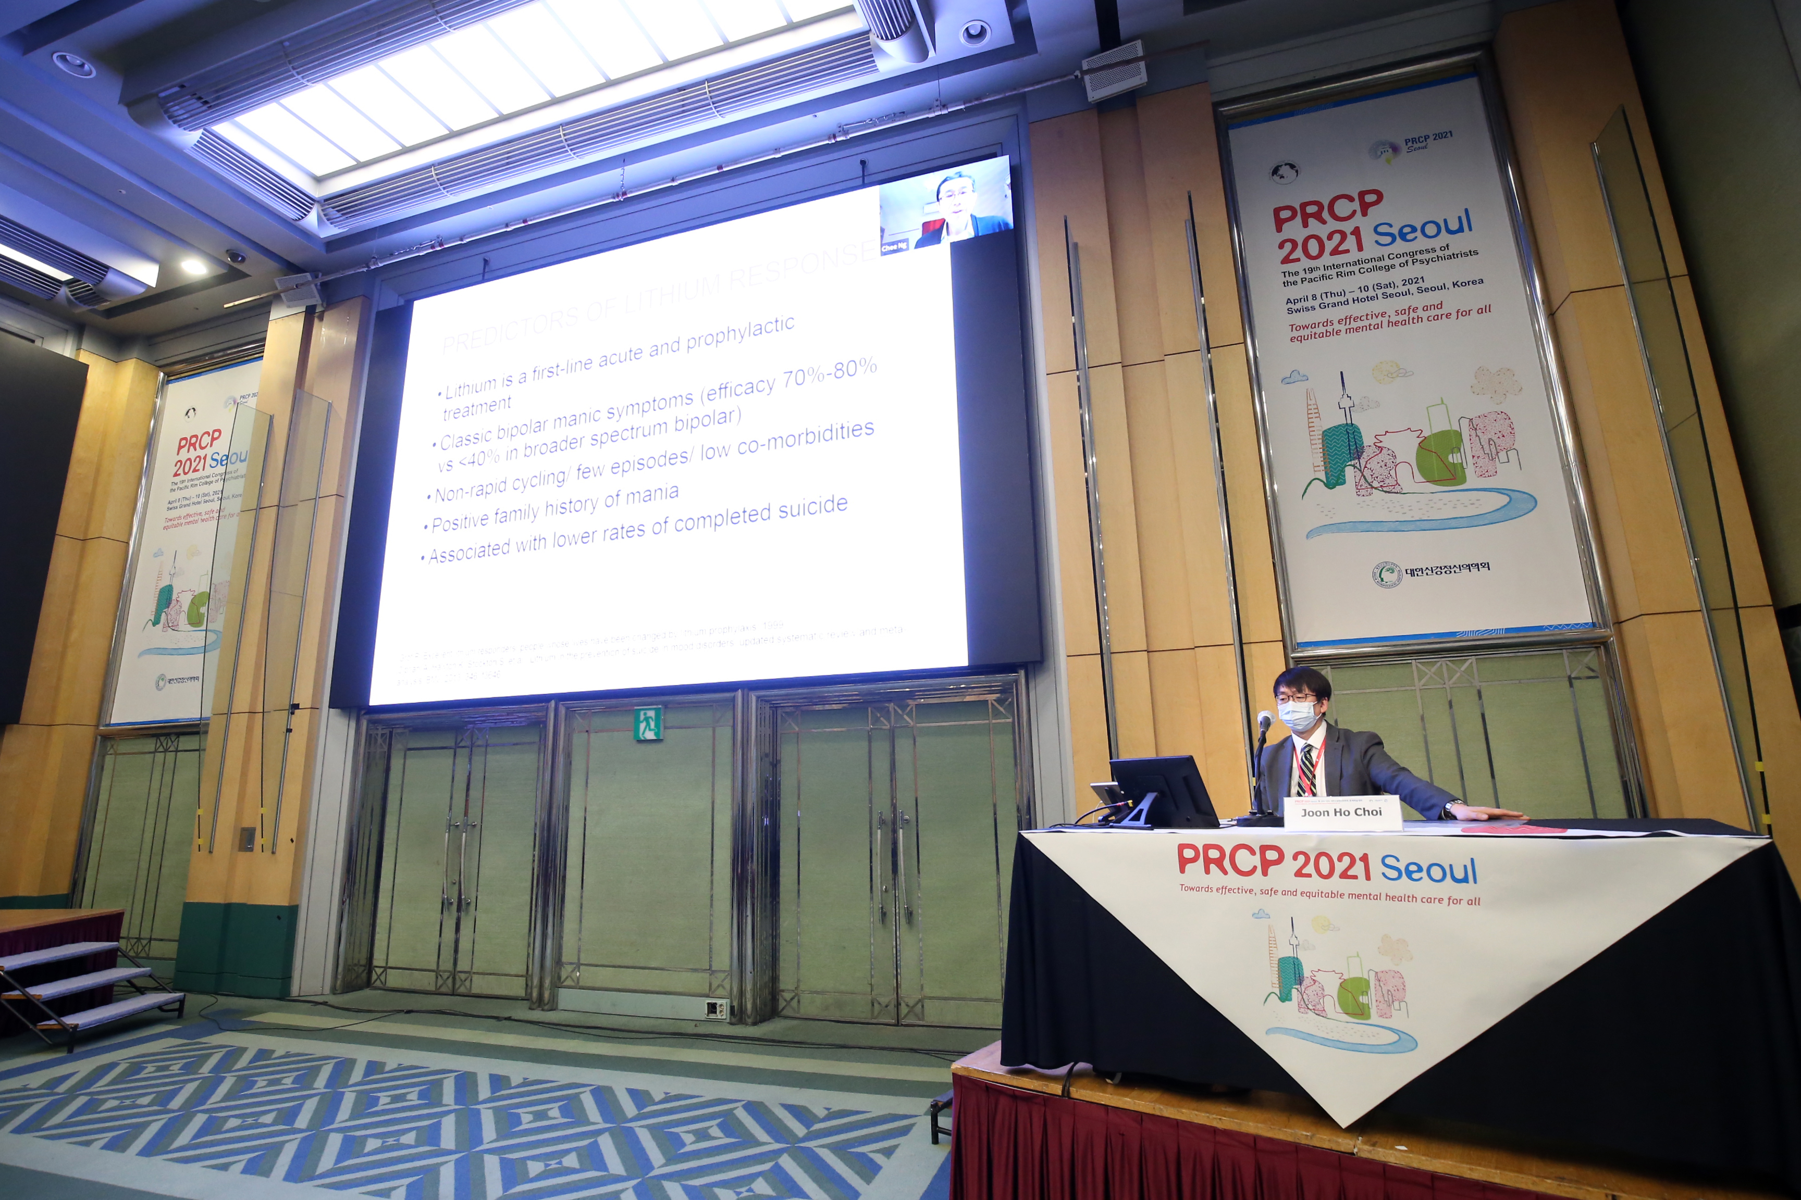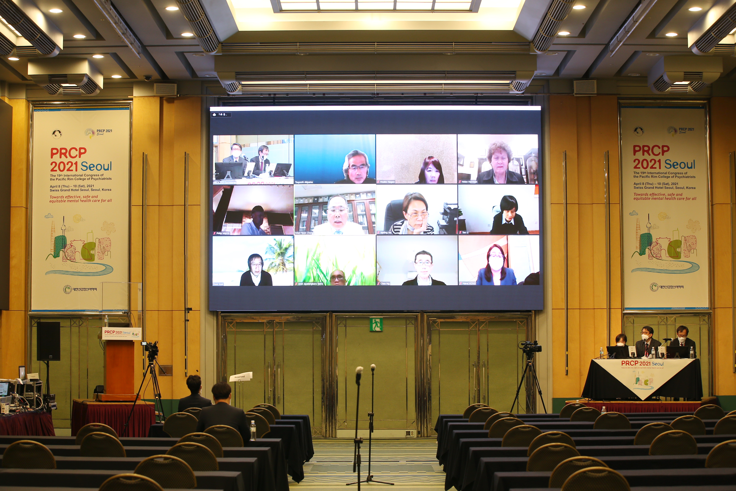

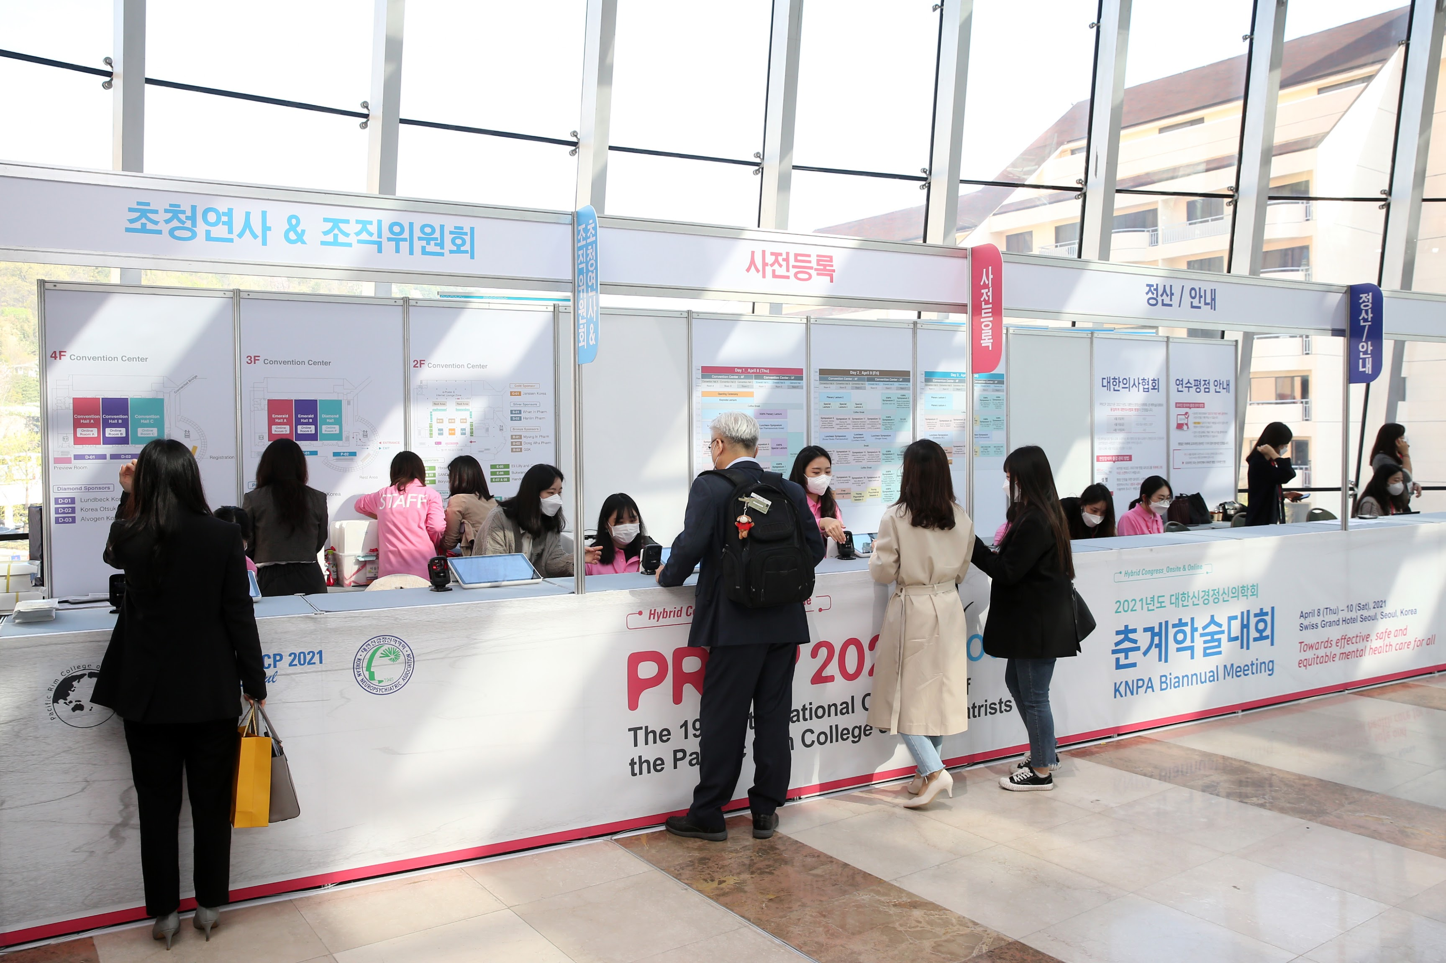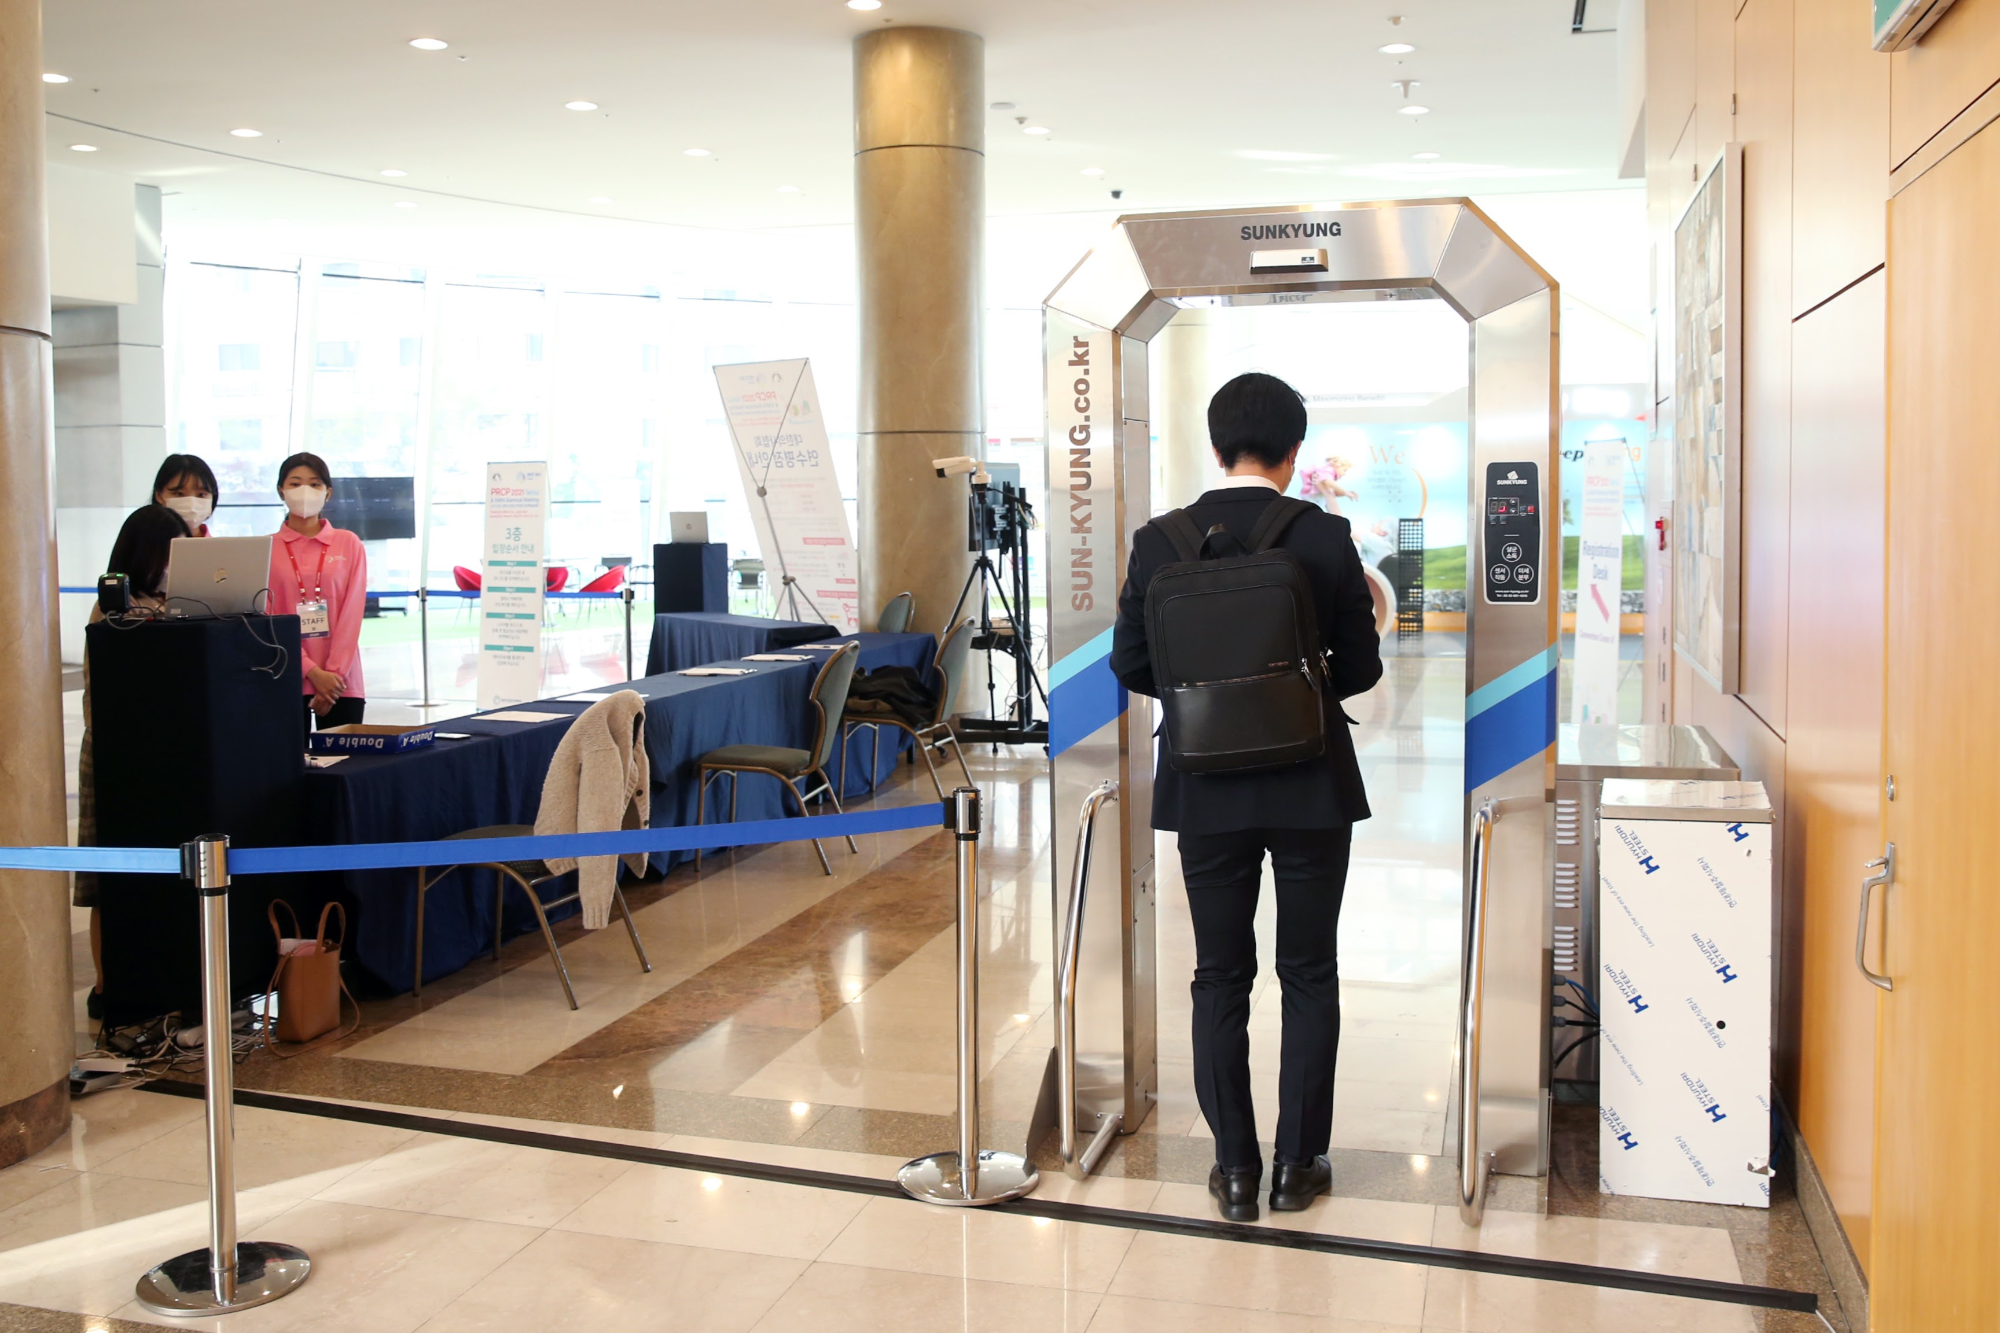

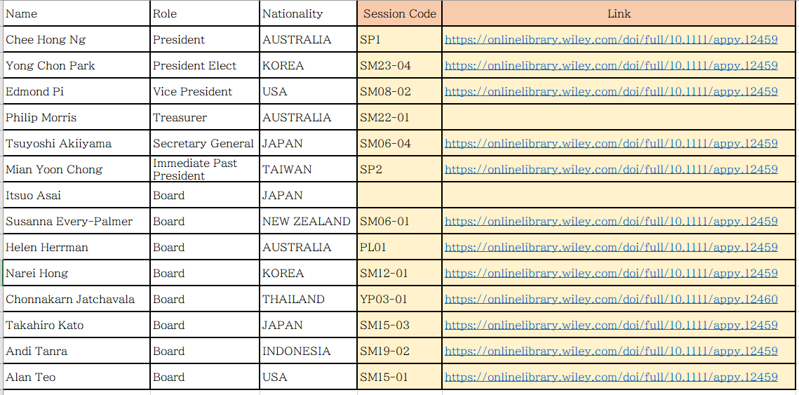

- PRCP Newsletter Editor’s Report

Dear PRCP Colleagues, I hope you enjoy our informative PRCP August 2021 Newsletter. This newsletter carries reports from the PRCP President, Secretary-General, Vice-President, Treasurer, the Asia-Pacific Psychiatry Journal, and messages from PRCP Board Directors.

The PRCP is a growing organization with new members joining this year. We are grateful for the continuing support of current members and look forward to the contributions of new members.

The Seoul Congress was a great success. The magnitude of this achievement is a tribute to the sterling work and innovation of the Organizing Committee who had to deal with the challenges of running a Congress in the midst of the Covid-19 pandemic. The hybrid nature of the meeting with local delegates participating face-to-face and overseas delegates participating via teleconferencing and video worked very well and meant members of our College were able to feel connected to each other and unified in the task or improving the training and practice of psychiatry in our region in order to better the mental health of our respective peoples.

The Asia-Pacific Psychiatry Journal goes from strength to strength and is publishing articles from authors and research teams across the Pacific Rim. It is truly becoming the ‘Voice of Academic Psychiatry’ for our region.

The Executive Committee of the PRCP Board met in late July via Zoom. Decisions made at this meeting will be announced soon via the next newsletter and on the PRCP website. One important announcement will be the date and site and venue of the next PRCP Congress. Hopefully it will be possible for this Congress to be held in the traditional way with us all meeting together face-to-face.

This newsletter is the informal way members of the PRCP can communicate with each other. In order to make this method of personal connection with colleagues more effective please send short reports or articles on items of interest and photos of yourself and colleagues for publication in the newsletter.

I look forward to your contributions.

Yours sincerely,

Prof Philip Morris AM
Newsletter Editor

2. PRCP President’s Report

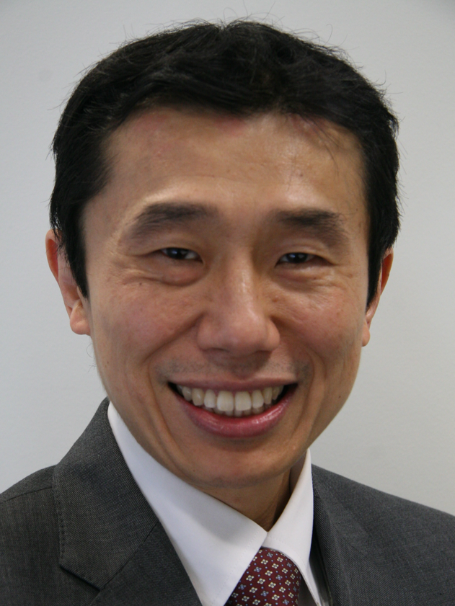

Dear Colleagues,

It is a deep honour for me to take up the Presidency of PRCP at this critical time for the PRCP, which was founded more than 40 years ago in 1980. I had the privilege of serving as an Officer of the PRCP previously as Secretary General (2006 - 2010), Treasurer (2010-2012) and President Elect (2018-2020). I am very appreciative of our PRCP Immediate-Past President, Prof Mian-Yoon Chong, for his dynamic leadership during the tenure of his presidency. He has led the PRCP in successfully organising workshops for the teachers of psychiatry, joint symposia, and co-sponsorship of regional conferences, and in sustaining the PRCP activities even throughout the pandemic restrictions.

I would also like to express my sincere gratitude to Prof Yong Chon Park and the organising team of the PRCP 2021, including Prof Kang Seob Oh, Prof Narei Hong, and many other organising and scientific committee members, for the successful delivery of the PRCP International Congress for the first time in its history as a hybrid conference both as an onsite meeting in Seoul and a virtual congress for international participants. We congratulate them on their outstanding achievement in the organisation of the PRCP Congress 2021 at the time of the COVID-19 pandemic which has understandably been very challenging.

I am also grateful to all the Officers of the PRCP who have supported the Executive Committee. I look forward to working with the newly constituted Officers and Board of Directors of the PRCP in managing the current affairs of the PRCP in the coming years. Together with the Board, we will endeavour to improve education and research in psychiatry, and promote greater collaboration in the Pacific Rim Region and with other regional associations and partners.

Chee Ng,MBBS, M.D.
President PRCP

3. President Elect’s report-

Dear colleagues,

The 19th International Congress of the Pacific Rim College of Psychiatrists (PRCP 2021) was held in Seoul, Korea on April 8 (Thu) – 10 (Sat) in the form of a hybrid congress featuring both online and onsite meetings amid the ongoing COVID-19 pandemic.
On behalf of the Organizing Committee, I extend my sincerest gratitude to all the participants for making your time to join us at PRCP 2021. We welcomed 971 participants from 22 countries, of which 294 joined the meeting onsite while 671 participated in the congress online. The following is a detailed breakdown of the number of onsite and online participants per day: on April 8, 183 joined the congress onsite, and 589 took part in the virtual congress; on April 9, 167 came to the onsite meeting, and 624 joined online; finally, on the last day of the congress, 91 registrants participated onsite, and 393 online.
Taking this opportunity, I would also like to thank the members of the Organizing Committee and the Board of PRCP as well as all speakers and chairs who enabled us to offer a high-quality and well-structured program and achieve a successful congress.
Under the theme of “Towards effective, safe and equitable mental health care for all,” PRCP 2021 covered the latest topics and advances in the field of psychiatry through a rich and varied scientific program. In particular, 155 abstracts were presented through free communication and e-Poster presentations. All abstracts including invited abstracts were published as a Wiley abstract book as well as a supplement of the Asia-Pacific Psychiatry. Moreover, we rewarded 13 participants for their outstanding abstracts in 4 categories: 4 with the Young Presentation Award, 3 with the Young Poster Award, 1 with the Best Presentation Award, and 5 with the Best Poster Award. The prizes included USD 700 for the Young Presentation Award, USD 500 for the Young Poster Award, USD 500 for the Best Presentation Award, and USD 300 USD for the Best Poster Award.
Last but not least, I would like to make a special mention of the virtual platform that we provided, which contributed to the great success of the PRCP 2021 hybrid congress. The PRCP 2021 virtual platform provided all participants with 4 main services: live sessions, sponsors’ exhibition, e-posters, and VOD’s. By running the interactive virtual platform, we offered participants the chance to send their questions to the speakers, and have the speakers answer them in real time. E-posters and VOD’s were available for participants to view at their convenience. Not only that, PRCP 2021 was accompanied by a virtual industrial exhibition which enabled participants to visit and learn about the latest industry news and innovations.
Under these progresses, the PRCP 2021 Organizing Committee was able to bring the congress to a successful conclusion. I would like to express once again my deep appreciation for your active support and contribution to PRCP 2021. I look forward to meeting all of you again, my dear colleagues and friends, at the next PRCP congress.

Sincerely,

Yong Chon Park, M.D., Ph.D.
President, Korean NeuroPsychiatric Association
Chairman, Organizing Committee of PRCP 2021

4. Vice President’s report-

4-1 - Tao Li

Dear PRCP Colleagues,

First of all, congratulations to Professor Chee Hong Ng on becoming the new PRCP president. I am confident he will bring his talent and expertise to this presidency. Meanwhile, I would like to thank Professor Mian-Yoon Chong and other Board members for your hard work and dedication during the past two years. I would also like to take this opportunity to welcome other new Board Members. The PRCP is growing stronger and more influential because of you.

It is my great honor to carrying on with my RPCP responsibility as a Vice President. I have learned so much from this job and from members of RPCP. I look forward to continuing our cooperation, both in research and in academic fields.

Time is tough with COVID-19 disrupting our work and life in various ways and magnitude, but never can it destroy our spirit and efficacy as leading psychiatrists in the Pacific Rim. Neither will COVID-19 stop our progress nor academic exchanges. It is our opportunity to shine as we consistently provide psychiatric services to the general public and advise governments on mental health issues. As vaccination moving forward in most countries, it looks like things are heading in exciting new directions. The cloud will be gone and we will soon be able to meet each other in person.

We’ve got this together. Keep safe and keep in touch.

Tao Li, M.D., Ph.D.
Vice President PRCP
Professor of Psychiatry
President, Affiliated Mental Health Center & Hangzhou Seventh People's Hospital, Zhejiang University School of Medicine, Hangzhou, Zhejiang, P R China

4-2 - Edmond H. Pi

Warmest greetings from Los Angeles, USA.

First of all, I would like again to express my most sincere appreciation and gratitude for electing me to serve as a Vice President of the PRCP, indeed this is a great honor and privilege for me. To look back for more than thirty years since I have first joined the College, I chaired the Scientific Program, served as Treasurer (1991-1997) and a Board member. All these beautiful memories have never faded away, it is still vividly fresh in my mind. It is wonderful to see that many exceptional leaders have carried the torch and made PRCP to grow steadily and shine. Undoubtedly under our President, Professor Chee Ng’s leadership along with the newly elected Officers and Board members, PRCP will continue to advance its mission and goals. I look forward to joining our current leadership group and continuing to further advance the achievements and success of the PRCP.

Recognizing the current world affairs, including the COVID-19 pandemic, we are living in an uncertain, unpredictable, and unprecedented time. The Pandemic caused by SARS-CoV-2 has disrupted holding medical conferences across the entire world. Despite facing all these obstacles, our Immediate Past President, Professor Mian-Yoon Chong and President-Elect, Professor Yong Chon Park successfully organized the 2021 PRCP Congress in virtual format. Congratulations! Trusting the pandemic too shall pass, we must work together and move forward, set our sights on 2021 and beyond, begin to review and reflect on the relevant issues, especially mental health during the Pandemic, in the Pacific Rim Regions, then overcome the challenges and prepare for the post-COVID-19 era, face whatever the new “normality” would be. While embracing globalization and worldwide swiftly shifting of the landscape of health and mental health in the recent years, there is an increased need and great urgency to work together in collaboration between us. The PRCP is an international organization and preeminently able to provide opportunities for international exchange, especially in the Pacific Rim Regions quite unlike any other professional organization. All these changes and challenges will provide great opportunities for PRCP to advance and grow. Together we, PRCP members, will be able to continue our established tract records in making significant contributions to advocate for our profession, improve treatment for people who need psychiatric care, exchange educational information to develop the future work forces, and promote research.

Lastly, we can proudly say that many PRCP members have consistently and continuously been very active in assuming the leadership role on the international scene in psychiatry. The exciting news to share is that our Past President, Professor Helen Herrman (Australia) now serve as the Immediate Past President of the World Psychiatric Association (WPA). our President-Elect, Professor Yong Chon Park is the Representative for Zone 17 (Eastern Asia) and a WPA Board member. In addition, I am deeply humbled and privileged to be elected as the Secretary for Scientific Meetings of the WPA.

Please stay safe and well during this uncertain and unpredictable time, hope to see you all again in the near future. Wishing you all the best.

Edmond H. Pi, M.D., Vice President

5. Treasurer’s report- Philip Morris

Dear PRCP Colleagues, I hope you enjoy our informative PRCP August 2021 Newsletter. This newsletter carries reports from the PRCP President, Secretary-General, Vice-President, Treasurer, the Asia-Pacific Psychiatry Journal, and messages from PRCP Board Directors.

The PRCP is a growing organization with new members joining this year. We are grateful for the continuing support of current members and look forward to the contributions of new members.

The Seoul Congress was a great success. The magnitude of this achievement is a tribute to the sterling work and innovation of the Organizing Committee who had to deal with the challenges of running a Congress in the midst of the Covid-19 pandemic. The hybrid nature of the meeting with local delegates participating face-to-face and overseas delegates participating via teleconferencing and video worked very well and meant members of our College were able to feel connected to each other and unified in the task or improving the training and practice of psychiatry in our region in order to better the mental health of our respective peoples.

The Asia-Pacific Psychiatry Journal goes from strength to strength and is publishing articles from authors and research teams across the Pacific Rim. It is truly becoming the ‘Voice of Academic Psychiatry’ for our region.

The Executive Committee of the PRCP met in late July via Zoom. Decisions made at this meeting will be announced soon via the next newsletter and on the PRCP website. One important announcement will be the date and site and venue of the next PRCP Congress. Hopefully it will be possible for this Congress to be held in the traditional way with us all meeting together face-to-face.

This newsletter is the informal way members of the PRCP can communicate with each other. In order to make this method of personal connection with colleagues more effective please send short reports or articles on items of interest and photos of yourself and colleagues for publication in the newsletter.

I look forward to your contributions.

Yours sincerely,

Prof Philip Morris AM
Newsletter Editor

6. Secretary General’s report - Tsuyoshi Akiyama

Since the last newsletter, the most significant event for the PRCP was, of course, the congress in Seoul. At the time of the congress the secretariat managed the board meeting and the general assembly. At the board meeting following issues were discussed.

Report of the 19th PRCP Congress
President's report
Membership updates
Financial Report
Withdrawal of Board Members
Slate of New Board Members
Slate of Officers
20th & 21st PRCP Congress
New President Report

After the board meeting and the general assembly, the new leadership of the PRCP was decided as follows;

Board member
Continuing members
Dr. Itsuo Asai, Dr. Susanna Every-Palmer, Prof Susan Shur-Fen Gau, Prof Helen Herrman, Prof Narei Hong, Prof Samuel Law, Dr. Hiram Mok, Prof Kang Seob Oh, Prof Tin Oo, Prof Andi Tanra, Prof Alan Teo.

Immediate Past President
Prof Mian Yoon Chong

Newly elected members
Prof Chonnakarn Jatchavala, Prof Takahiro Kato, Prof Ahmad Hatim Sulaiman, Prof Huali Wang, Prof John Chee Meng Wong

Officers
President
Prof Chee Ng

President-Elect
Prof Yong Chong Park

Vice Presidents
Prof Tao Li, Prof Edmond Pi
Prof Chee Ng may select the third Vice President in conjunction of the future PRCP Congresses.

Treasurer
Prof Philip Morris

Secretary General
Prof Tsuyoshi Akiyama

Under the renewed leadership the PRCP will continue developing its activities and the secretariat will serve as efficient instrument for the development.

Tsuyoshi Akiyama
Secretary General PRCP

7. Asia-Pacific Psychiatry editor report –

Report of the Editor in Chief
Allan Tasman, MD

I continue to be honored to serve as Editor in Chief of Asia Pacific Psychiatry (APPSY), which now is in its 13th year of publication, having been joined in recent years by the Asian Federation of Psychiatric Associations (AFPA) as their official journal. The metrics report provided by our publisher, Wiley/Blackwell, indicates that our submission rates have continued an upward trend and the acceptance rate has remained low, indicating our journal is seen as highly competitive. Approximately 440 submissions were processed in 2020 with an acceptance rate around 15%. Our submission rate has increased steadily since our agreement to also serve as the official journal of AFPA. The journal's most recently released Impact Factor is 2.51, resulting in our moving up nearly 20 positions in the ranking of all psychiatric journals since the last report. This change reflects the excellent work of our reviewers and associate editors in selecting the highest quality submissions for consideration by me.
We continue to be well served by our publisher, Wiley-Blackwell, which has continued to publish the journal under the agreement I originally negotiated at no cost to PRCP and with a provision for a profit sharing agreement which brings PRCP a small income each year.
I have solicited a number of special issue topics for the journal over the past year. The current publication year has been marked by a special issue on Transcultural Adaptions of Psychotherapy in the Asia Pacific Region with guest editors Cesar Alfonso, Chair of the WPA Section on Psychotherapy, and Michel Botbol, WPA Secretary for Publications. Another special issue for the current year on the topic of Global Perspectives on Suicide Prevention is being guest edited by Gabriel Ibvijaro, past president of the World Federation for Mental Health, and will be published in the fall 2021 edition. A third special issue, likely for early 2022, on the topic of Innovative Programs for Medical Student and Post Graduate Education in Low- and Middle-Income Countries, is underway in conjunction with the WPA Section on Education, with Andrea Fiorillo, Chair of the section, serving as guest editor.
We have benefitted greatly from the outstanding contributions of our Deputy Editor-in-Chief, Chee Ng and our Associate Editors Renato Alarcon, Helen Chiu, and Yutao Xiang. Dr Alarcon has recently indicated his wish to retire from his position after a number of years of outstanding service. The PRCP Board has authorized a formal letter of commendation and thanks to Dr. Alarcon for his outstanding service. We are currently seeking applications or nominations for positions of Associate Editor.
Several issues regarding the organization and review process of the journal will be undertaken this year. These include:
- A review of the organization and roles of the editorial board.
- A review of the organization and functions of the editorial leadership, including review of the specific assignments of the various associate editors. To expand the ability to publish an even more diverse set of articles, new editorial positions may be created.
- A review and revision of the article review process and reviewers.
- An initiative to maximize the participation of AFPA in the editorial leadership and review processes.
I welcome any suggestions to enhance the quality of the journal and thank you for your ongoing support.

Allan Tasman,
Editor in Chief (Founding editor 2008-2012) and Past PRCP President (2006-2008)
Professor Chee Ng
Deputy Editor-in-Chief

8. PRCP Website

Renew your PRCP membership through our website

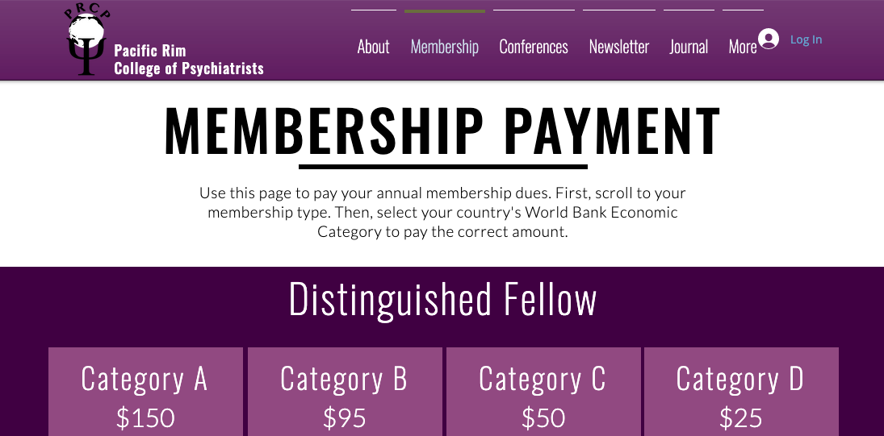

Have you received your membership renewal reminder but not responded yet? Or do you have a colleague interested in joining PRCP?

You can quickly and easily use the updated PRCP website to help.

All you need is to have a PayPal (https://www.paypal.com/) account for electronic payment, and to visit our membership page (https://www.prcp.org/membership-payment). Once there, find your category of membership (Distinguished Fellow, Fellow, or Member). If you are renewing your membership, this information is provided in your reminder email. If you are unsure, email us at info@prcp.org. Then, determine which World Bank economic category your country of residence falls into. If you are unsure, that information is listed here (https://www.prcp.org/world-bank-economic-categories). Click on the “Buy Now” icon that matches your category, and complete your payment. That’s all.

Thank you for being part of the PRCP family!

Alan Teo, M.D., M.S.
Associate Professor, Oregon Health & Science University
Core Investigator, Center to Improve Veteran Involvement in Care
@DrAlanTeo & www.DrAlanTeo.com

9. Messages from our new board members

9-1. Chonnakarn Jatchavala

Hello, from Songkhla, Thailand

My name is Dr. Chonnakarn Jatchavala, a new member of Board of Directors of Pacific Rim College of Psychiatrists (PRCP). Let me introduce my training and experience a bit, I obtained my M.D. degree and military background from the Phramongkutklao College of Medicine (Royal Thai Army), Bangkok, Thailand, in 2010. I have been certified the Thai Board of Psychiatry from the Royal College of Psychiatrist of Thailand in 2013 and graduated MSc. in Children and young people mental health from the University of Edinburgh, Scotland in 2015. My current position in Prince of Songkla University has been Assistant Professor of Psychiatry and professional lecturer (PSU-TPSF) since 2017.
I wish I can be a part of PRCP which can be beneficial for all members. According to my position and age, it seems I can use them for devoting myself to connect among senior, junior psychiatrists, trainees, and medical students for PRCP’s missions.
Very truly yours
Chonnakarn Jatchavala

9-2. Wong Chee Meng

Academic psychiatry development is a relatively young entity in Singapore, dating back to recent years of 1979, with the establishment of the Department of Psychological Medicine at the National University of Singapore.
Together with its partnering teaching hospitals, it has steered the undergraduate psychiatry training of close to ten thousand medical students, graduated a hundred specialists in postgraduate Master of Medicine Psychiatry qualifying exams staffing many generations of psychiatrist positions in the eighties and nineties. And propelled many Ph.D. graduates in neuroscience and mental health research in these past 40 years.
These pay tribute to the rapid development of the mental health professional workforce in Singapore of today. Some students from overseas have also returned to their home countries in the region to serve their mental health services after graduation.
These academic psychiatry programs in education and research form the bedrock of our clinical practices, with many professional collaborations and friendships forged with our psychiatrist and psychologist colleagues from the Asia Pacific countries. This has greatly benefited our people and their home countries.
The opportunity to serve in the new PRCP Council and its community is a privilege for me to learn, bring along many more of my colleagues to collaborate and contribute with our overseas peers to address current mental health challenges, and shape the future development of psychiatry education, training, and research across borders.
Today, the mental health challenges of Youth with depression and its associated rising suicide rates, and the ageing population’s depression and dementia assessment and care needs, are two key areas that augur well for cross-national collaboration and joint development in education, training of mental health professionals and researchers to elevate the best practice standards.
I trust PRCP under the new leadership of Professor Chee Ng, with great emphasis on cross-national collaboration in mental education and research would further improve the mental health practices and quality care delivery in the region, and further advance PRCP staying relevant to its missions.

9-3. Takahiro A. Kato

I am very much honoured to take a role as a board member of PRCP since 2021. My first attendance of the PRCP congress was 2009 in Tokyo, in which I met Dr. Alan R. Teo from USA during the young psychiatrists’ workshop. Since then, we have successfully conducted a variety of international research focusing on pathological social withdrawal, hikikomori, and modern depression. In this regard, I would like to express my great thanks to the PRCP.
Now, in addition to research and clinical works focusing on cultural and social psychiatry, I am also engaged in biological research targeting brain immune cells-microglia, which may deeply contribute to a variety of mental disorders. Based on my research background, I hypothesize that culture must produce our unique brain-mind networks in each individual and culture/society-related stress may result in unique psychiatric outcomes in each country and area by disturbing neuron-glia networks. I believe that PRCP is one of the best places to clarify the above hypothesis and to make a solution to such difficulties. Now is the hard time in psychiatry facing many difficulties including social isolation issues, suicidal issues, problems cause by aging, and the COVID-19 pandemic.
I would like to collaborate with all the PRCP members to establish better clinical practice in psychiatry and better mental health in the Asia-Pacific region.

Takahiro A. Kato, M.D., Ph.D.
Associate Professor, Department of Neuropsychiatry, Graduate School of Medical Sciences, Kyushu University
Chair, Mood Disorder/Hikikomori Research Clinic, Kyushu University Hospital
Fukuoka, Japan

9-4. Ahmad Hatim Sulaiman

Dear PRCP Colleagues,
Greetings from Malaysia. I hope you are keeping safe and healthy during this challenging period. I would like to express my sincere appreciation and gratitude for electing me to serve as a new member of the Board of Directors to the PRCP. I wish to acknowledge and thank all the Executive Council members and Board of Directors for their support. It is a great pleasure and honor for me to be part of PRCP which is an international organization with a proud past and an exciting future.
As for a short background about me, I am the Head of Department and Professor of Psychiatry working in the Department of Psychological Medicine, Faculty of Medicine, University of Malaya, Kuala Lumpur. I am also the President Elect for Malaysian Psychiatric Association.
I hope that we will be able to work together and continue to build on our strengths and professionalism through education, research, training and resources. We will also retain our commitment to ensure that all of us are able to perform our critical role: to promote mental health and treat mental illness.
I wish all of you the best and together we will bring PRCP to greater heights.
Prof Dr Ahmad Hatim Sulaiman
Board of Directors PRCP

9-5. Huali Wang, MD/PhD

It is my privilege to join PRCP and serve the Board of Directors. I have been practicing geriatric psychiatry for 22 years. Also, I have the honor to serve the leadership of the Chinese Society of Geriatric Psychiatry and Alzheimer’s Disease International (ADI).
The aging population is proliferating in Pan Pacific Region. The number of persons having mental health and behavioral problems is increasing dramatically. For example, dementia has become an epidemic; depression is commonly reported; loneliness and social exclusion are significant concerns. Therefore, improving service capacity and promoting mental healthcare for older adults has become the priority in the region.
In the past decades, health professionals and clinical researchers have endeavored to improve geriatric mental health in the region:
- examining the impact of mental health and behavioral problems on the aged population
- identifying the optimal instruments for early detection and timely diagnosis of mental disorders such as late-life depression and dementia
- establishing the culturally appropriate interventions to improve the outcome of mental disorders
There are also a few examples of international academic exchange within the region. However, the existing collaborations might be fragmented. There exists an urgent need for strengthening the collaboration on old age psychiatry in the region.
As one of the Board Members, I would be enthusiastic about calling the joint efforts of the PRCP members to promote geriatric mental health. We will further explore the potential opportunity to conduct collaborative research, share local experiences and practice, and ultimately contribute to the better mental well-being of older adults in the region.
Huali Wang, MD/PhD
Professor of Geriatric Psychiatry
Chair, Clinical Research Division
Peking University Institute of Mental Health, Beijing, China

10. List of PRCP Office Bearers and Board Directors

President |  | Board of Directors
Chee Hong Ng | (Australia) | Itsuo Asai | (Japan)
President Elect |  | Susanna Every-Palmer | (New Zealand)
Yong Chon Park | (Korea) | Susan Shur-Fen Gau | (Taiwan)
Vice President |  | Helen Herrman | (Australia)
Tao Li | (China) | Narei Hong | (Korea)
Edmond Pi | (USA) | Chonnakarn Jatchavala | (Thailand)
Treasurer |  | Takahiro Kato | (Japan)
Philip Morris | (Australia) | Samuel Law | (Canada)
Secretary General |  | Hiram Mok | (Canada)
Tsuyoshi Akiyama | (Japan) | Kang Seob Oh | (Korea)
 |  | Tin Oo | (Myanmar)
Immediate Past President |  | Ahmad Hatim Sulaimam | (Malaysia)
Mian Yoon Chong | (Taiwan) | Andi Tanra | (Indonesia)
 |  | Alan Teo | (USA)
 |  | Huali Wang | (China)
 |  | John Chee Meng Wong | (Singapore)

11. Application for membership

APPLICATION FORM FOR MEMBERSHIP OF
THE PACIFIC RIM COLLEGE OF PSYCHIATRISTS
DATE
TITLE
FIRST NAME
LAST NAME
DATE OF BIRTH
COUNTRY: GENDER:
CURRENT POSITION
MAILING ADDRESS
HOME PHONE : FAX:
OFFICE PHONE
E-MAIL
SPECIALIST BOARD: DATE RECEIVED:
􀂉 PSYCHIATRY
􀂉 NEUROLOGY
􀂉 OTHER (PLEASE SPECIFY)
CURRENT INTERESTS:
􀂉 CLINICAL
􀂉 TEACHING
􀂉 RESEARCH
􀂉 CROSS CULTURAL
SPECIALIST TRAINING:
QUALIFICATIONS:
YEARS WORKED AS PSYCHIATRISTS:
MEMBERSHIP OF NATIONAL ASSOCIATIONS:
INTERNATIONAL ACTIVITIES
Please return this form with your CV and one passport photo to the PRCP Secretariat located at:
Department of Neuropsychiatry, NTT MEDICAL CENTER TOKYO
5-9-22 Higashi-gotanda, Shinagawa-ku, Tokyo 141-8625, JAPAN
Phone: + 81 3 3448 6508 Facsimile: + 81 3 3448 6507
E mail: info@prcp.org
*PRCP recognizes World Bank Economic Categories. Please see the PRCP website for details: www.prcp.org/members.html
