PRCP Newsletter Summer 2020

Newsletter Contents

Headline Announcement
The 2021 Seoul PRCP Congress is on schedule and is calling for submission of a symposium, workshop, lectures, and free paper presentation.

1. Newsletter editor’s report - Philip Morris
2. President’s report – Mian-Yoon Chong
3. President Elect’s report - Chee Ng
4. Vice President’s report- Yong Chon Park
5. Treasurer’s report - Philip Morris
6. Secretary General’s report - Tsuyoshi Akiyama
7. Asia-Pacific Psychiatry editor report - Chee Ng
8. PRCP Website is renewal. https://www.prcp.org/membership-payment - Alan Teo
9. Message from our new member - Bao-Liang Zhong
10. Covid-19 virus – Public Health Response – Philip Morris
11. List of PRCP Office Bearers and Board Directors
12. Application for membership

1. PRCP Newsletter Editor’s Report
Dear PRCP Colleague, it is now eight months since the start in most of our countries of the Covid-19 pandemic. How life has changed. It seems like 2019 was a year from an earlier century!

While the public health approach to the pandemic is relatively well known, the application of these principles has been different in each of our countries. This has resulted in varying outcomes in terms of the number of infections and deaths from the virus. Some countries have done very well in suppressing or eradicating the virus – China, Taiwan and New Zealand stand out. Most of our PRCP member countries have been able to avoid their medical systems being overwhelmed. This is a very welcome result.

However, all nations need to be continually vigilant to keep this virus at bay. Any loss of focus on public heath measures to contain the virus can lead to an outbreak or ‘second wave’. This is what happened recently in the state of Victoria in Australia. The resultant ‘lock-down’ of the population here only now is bringing the infection rate under control. In Australia we have found that elderly and infirm people living in aged care facilities and nursing homes are particularly at risk.

Community-wide ‘lock-downs’ and other measures to reduce interaction between people are being employed across nations to control the spread of Covid-19. While these measures are often necessary and are the only way to suppress community transmission of the virus, they are causing dramatic effects on individuals, families and communities. Unemployment is increasing rapidly, businesses are failing, isolation of individuals is taking its toll, and we are seeing increasing signs of mental distress, particularly among vulnerable individuals and those who have lost family and friends to this virus.

The mental heath consequences of this pandemic will need to be monitored, alleviated, and prevented where possible. If the experience of previous pandemics is any guide, the adverse mental health effects will intensify with the growing economic damage caused by the virus. The PRCP is well placed to advise our health care colleagues and governments about this problem. A number of articles in this newsletter address the pandemic.

In the midst of all this international upheaval the PRCP continues to function and support our members and colleagues throughout our region. The most important upcoming event is the 19th PRCP Congress in Seoul, Korea to be held at the Grand Hilton Hotel from Thursday April 8 to Saturday April 10, 2021. The Congress convener, Prof Yong Chon Park, reports on progress toward this meeting in the newsletter. In addition we have reports from the PRCP President, President-elect, Secretary-General, and Treasurer.

I hope you enjoy reading this newsletter. I look forward to (hopefully) meeting you in person in Seoul in April next year. If you have any comments about items in this newsletter please get in touch with me at the PRCP office email (ntt.psychiatry@gmail.com) or my direct email (pmorris@iprimus.com.au).

Yours sincerely,

Prof Philip Morris AM
MBBS, BSc med, PhD, FRANZCP, FAChAM (RACP), DABPN
Newsletter Editor

2. PRCP President’s Report

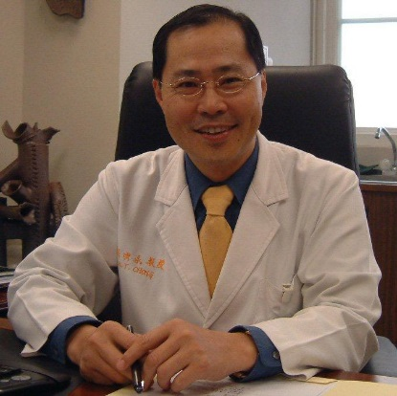

Dear Colleagues,

I hope you are safe and well as we are going through a difficult period in this global pandemic of Covid-19. Since the beginning of this year, its outbreak has caused considerable impact to our community and daily living where many places are lockdown in a form or another with much restrictions in human activities. Although most countries have taken drastic measures to combat the problems, but many failed to contain the virus due to mismanagement by their incompetent leaders who do not believe in science and medicine and instead putting their political interests above all human lives. The infectious disease however observes no international boundaries and with trend of increasing cases of daily morbidity and mortality, there is no sign that the condition is going to get better in near future.

Because of the pandemic and travel restrictions, many academic activities were deferred or suspended, and conferences were either cancelled, postponed, or conducted virtual meetings in a much smaller scale. We have no exceptions and had to cancel the PRCP-TOP training workshop that was scheduled to take place in April in Changsha, China. Prior to the Covid-19 pandemic, we were able to co-sponsoring two TOP training workshops in 2019. One was in Jan 18-23, 2019 at the National University of Singapore, Singapore, and the other was on July 20, 2019 held in conjunction with Quest International University in Ipoh, Malaysia. We were also a co-sponsor of the 7th World Congress of Asian Psychiatry (WCAP) held by AFPA in Sydney, Australia from Feb 21-24, 2019, and the AsCNP-ASEAN 2019 Congress in Feb 28-Marh 3, 2019 organized by Professor Andy J. Tara in Yogyakarta, Indonesia. Many of our colleagues had actively participated in the above conferences.

Fortunately, our biannual international congress which was designated in 2020 had been averted to 2021 by the Executive Committee during the meeting at Sydney in February 2019, to avoid the adjacent meeting of WPA 2020 Congress in Bangkok. But all major international congresses in 2020 including the WPA Bangkok congress are now deferred to 2021, who knows what will happen next year if the pandemic is not under control.

The 19th international Congress of PRCP is organized by Professor Yong Chon Park. On Jun 16, 2020, the PRCP Executive Committee had a ZOOM meeting with the organization committee of the 19th PRCP International Congress and reiterated that the congress will proceed as schedule in April 8-10, 2021 at the Grand Hilton Seoul, Seoul, Korea. Please keep the dates and I hope we can see each other in Seoul next year and could enjoy the lovely spring and the spicy Korean cuisine and their warm hospitality. The Koreans have a good track record of organizing meetings, and I deeply believe that they will organize a safe and successful meeting in 2021.

As far as I know, many of our colleagues are now involved with the work and study of mental health related to the pandemic. It will be another focus of discussion at our 2021 International Congress in Seoul. Please be prepared to submit your proposal on these and other topics for conferences, workshop, forums, and presentations. And in the meantime, please visit our new PRCP website for any updates. The website was revised and organized by Professor Alan Teo in 2019, and please feel free to give him your feedback regarding the website that belongs to all of us.

Finally, please do not forget to take care of yourself while taking care of your patients. Keep fit and safe and I will see you next year in Seoul.

Best wishes,

Mian-Yoon Chong, MD., PhD., FRCPsych
President, PRCP
Professor of Psychiatry, Chang Gung University School of Medicine, Taiwan
Vice-Superintendent, Chang Gung Memorial Hospital, Chiayi, Taiwan

3. President Elect’s report-Chee Ng

Within the last 6 months, the world as we know it has been changed profoundly by the COVID-19 pandemic. Life-saving public health measures, such as physical distancing, mandatory quarantines, and restrictions on travels within and between countries, have transform clinical practice, training and education and professional activities. While the pandemic rages on, virtual communities and communication, whether socially or professionally, are the norm for our interactions with each other.

Hence, it is more important than ever that the PRCP continues to maintain the professional activities of the college and communication between our international memberships. While several international psychiatric conferences have been postponed until next year, the 19th PRCP Congress will be on schedule from 8 April (Thu) to 10 April (Sun) 2021. Ably led by Prof Yong Chon Park, the Vice-President of PRCP, and his capable local organizing committee, the Congress will develop an outstanding scientific and program educational to enrich all participants.

In addition, due to the fear of contagion, long term social isolation, stigma and inevitable socioeconomic downturn as a result of the pandemic, the impact on population mental health is enormous. Those with pre-existing mental health problems are likely to face even more psychological stress. Further, the pandemic has also impacted on the way mental health services are delivered which will affect both patients in hospitals and in the community. We would therefore encourage the PRCP members to share their experience of coping with the pandemic and also adapting their clinical practice. We should find ways to maximise our existing support structures as well as to promote self-care during these challenging times.

Professor Chee Ng MBBS, MD, FRANZCP
Healthscope Chair of Psychiatry, The Melbourne Clinic
Professor of Psychiatry, The University of Melbourne
President-Elect PRCP

4. Vice President’s report- Yong Chon Park

Dear colleagues,
I hope our PRCP colleagues are staying safe and healthy during the pandemic. I wanted to share my observations and experiences dealing with the pandemic in Korea.
#1 Scientific Meeting.
As COVID-19 began to spread slowly, most of the meetings started getting postponed. Smaller meetings were postponed initially, however, the overall impact to society was not too severe yet and some even took those days as unexpected holidays. Any doctor might be able to recall the sense of relief when examination was delayed while attending medical school.
As the COVID-19 became the pandemic and travels were restricted, everybody started to feel the impact and worried about the future. All of the scientific meetings of each medical association were delayed from April to July. At around the end of May, Korean Neuropsychiatric Association (KNPA) realized that we could not delay the scientific meeting anymore and decided to proceed with the meeting on July 9th-10th in Seoul. We had no model case and became the one of the leading groups hosting a nation-wide scale scientific meeting.
Throughout May and June while we were preparing for the meeting, we had decided to follow the guideline from the Korean government: to keep the social distance and wearing the mask, washing and sanitizing hands, checking the body temperature at the entrance. We also had installed air washing machine with sanitizing sprays. To keep the social distance we had limited on-site participants within 600 persons, which was the maximum number the venue can support without safety concerns. The registration was full in 2 days and there were many who could not register further. Considering this unprecedented environment, government allowed on-line participation to obtain the CME point. Thanks to the on-line participation, the number of participants was the highest among the past several years.
We had proceeded with hybrid model (on-line and off-line) of scientific meeting for the first time among the national scale scientific meeting. During the one symposium we used the virtual presentation from the speaker at the University of Pennsylvania. Despite the time differences, the speaker presented without any problem and real time Q&A at the conference room was performed successfully. Some domestic speaker used the pre-recorded video presentation which could not cover Q&A. Overwhelming number of on-line participants were able to stay on-line until the end of each session. On-line Q&A was performed via online messaging system. The chairman controlled both on–line and off-line Q&As.
Probably the most critical component that we could call success out of the meeting was whether we had any confirmed cases of COVID-19 from the participants after the meeting. We patiently waited for two weeks. Three weeks after the scientific meeting, we were able to declare that we hosted successful meeting under COVID-19 environment.
The reason why I described such a detailed manner is because we have witnessed that we can still hold scientific meetings with extra care and preparedness. The team of KNPA scientific meeting is also key members of 2021 PRCP organizing committee. I am sure they can do it successfully with the collaboration of PRCP leaders.
With this experience we can think of a few scenarios.
- If the Pandemic ends within the April of 2021, we can proceed the PRCP meeting as usual.
- If the Pandemic persist until and after April of 2021, we can proceed with hybrid model, both on-line and off-line.
- Postpone the meeting is not considered as an ideal option at this point.
- If we proceed on-line form, the most important thing is the contents, so the speaker and presentation material should be really intriguing.
- For the convenience of the on-line participants the delivery system should be cutting-edge technology, so the ‘user-experience’ of the participants is exceeding their expectations.

#2 Repeated tragedy in psychiatric society
In Korea, we had experienced such a shocking trauma that the young prominent professor of psychiatry Dr. Se-Won Lim was killed by the psychotic patient on December 31st, 2018 in his outpatient office. No longer than 2 years, same incident occurred. In Busan, the second largest city in Korea, Dr. Je Won Kim who managed his own clinic with 20 inpatients was killed by a patient. The patient had been disrupting the hospital rules and other patients were suffered from his uncontrolled behavior. The doctor asked not to smoke at the hospital but the patient refused and threatened the staffs. The doctor ordered discharge; however the patient did not follow and purchased the knife to make the disturbance. The doctor was wounded by the patient and the patient walked out of the room to attack the other people. The doctor shouted out to escape, and then the patient returned to the doctor and stabbed him to death.
A month before, there was a similar incident happened to a female doctor. Arguing for no reason that the doctor is doing too many interviews with the patient, he hit the doctor with his mobile phone onto her head and arms. The police were called and the patient was taken to the police office. However, the police released the patient and the patient re-appeared at the hospital to see her next morning. With complaints from the hospital staffs the police have sent the patient to another hospital to be admitted. When I visited her, she was trying to suppress her mind; I was sure that she was suffering in the post traumatic experience. At that time, I worried the same incident will occur soon, however it comes so fast and so tragic.
The officer of the health and welfare visited the funeral and promised to discuss the prevention of the accident. Unfortunately, they promised “to discuss” not “provide the solution of reoccurrence”.
We were highly disappointed by the level of attention that the government and the public showed against these recent, repeated incidents. Nevertheless, we are attempting public hearing at the National Assembly with some lawmakers to revise the mental health law which was distorted by the stakeholders in the absence of the psychiatrists.
I will keep you updated on the progress of our efforts.
As you may have assumed, Korea is the fast-changing country. That contains pros and cons. It seems that Korean psychiatrists are riding on a running tiger: a lot of changes that are difficult to deal with under a fast-paced environment. Looking on the bright side, making changes is much better than standing still- as long as we can expect positive results.

Yong Chon Park
President of Korean Neuropsychiatric Association.
Vice president of PRCP
Chairman of 2020 PRCP organizing committee

5. Treasurer’s report- Philip Morris

Dear PRCP Colleagues, it is my task to present the Treasurer’s Report for financial year 2019 (1 January 2019 to 31 December 2019). Please see the financial statement below.

As you can see we budgeted for an income of Yen (Y) 1,120,100 and expected expenses of Y 1,039,400. Unfortunately we did not meet our budget goals.

There was an income shortfall of Y 105,279. This represents a 9% reduction in expected income. The main causes of this reduction were an overestimation of membership fee income in the budget and the royalty from our Asia-Pacific Psychiatry Journal was less than anticipated.

There were additional expenses of Y 708,714. This represents 68% increase in expenditure over the budgeted amount. The main causes of this increase were the expenses incurred from an unbudgeted meeting of the PRCP executive in Sydney in 2019, extra costs than were expected to move the PRCP website to a new web company in the USA that included a one-off start-up fee, an additional credit card fee that had not been correctly estimated in the budget, and office expenses over budget due to the purchase of a more capable office personal computer.

The small reduction in income and the much larger increase in expenditure meant that instead of a budgeted surplus (profit) of Y 80,700 we incurred a deficit (loss) of Y 733,293 in 2019.

Although this result is concerning, the majority of the causes of deterioration in the profit and loss statement are one-off expenses (website, Sydney meeting, credit card payment, and personal computer purchase) that are unlikely to be repeated. Close scrutiny of the expenses side of the budget will be needed to prevent this situation occurring again.

Our overall financial position is sound. Our total assets are Y 13,603,924 held in cash. We have a liability of Y 1,468,300 held for the Fellowship Award Fund.

I present this financial report for your consideration.

I wish to thank Hisako and Tsuyoshi for all the hard work put into preparing the financial balance sheets.

Prof Philip Morris AM
Treasurer PRCP

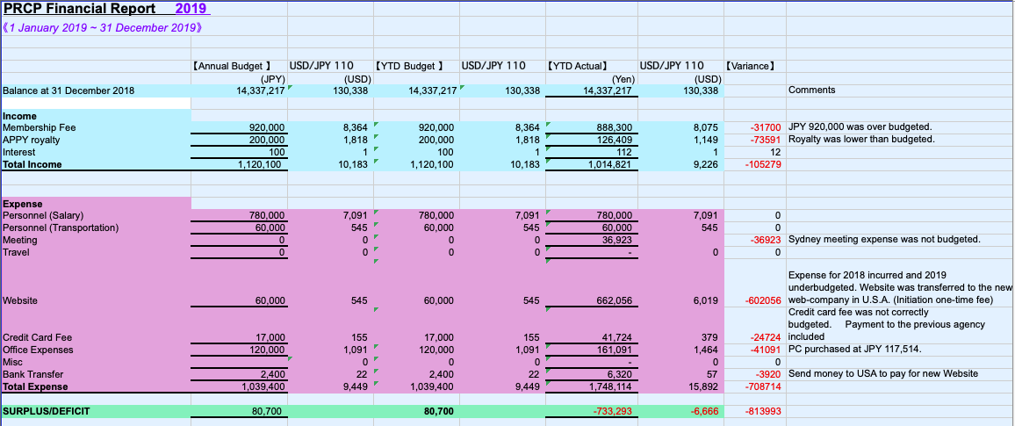

6. Secretary General’s report - Tsuyoshi Akiyama

Since the Newsletter 2019, the secretariat has carried out the tasks below to support the activities of the PRCP.
Transfer of the PRCP web to America
With the discussion with the Executive committee, it was decided to renew the PRCP web and transfer it to America. The secretariat worked with the Japanese agency to sort out the necessary information for the transfer. Now the PRCP members can enjoy a more efficient PRCP web.
Upgrading of payment acknowledgment
The credit card agency was changed from a Japanese company to Paypal. Along with this change the secretariat upgraded the payment acknowledgement system so that the certificate of payment would be sent automatically.
New members
The PRCP has received application of five new members, as follows;
-Dr. Paul Fung（Australia)
Interest area: Youth Mental Health; Primary Mental Health Service Delivery; Technology in service delivery; global mental health
-Dr. Hannah Kim (South Korea)
Interest area: Consultation Liaison Psychiatry
-Vincent Chin Hung Chen （Taiwan)
Interest area: Child & Adolescent Psychiatry
-Aye Myat Thuzar (Myanmar)
Interest area: Research of Mood Disorder
-Bao－Liang Zhong （China)
Interest are: mood disorders and old age mental health services
If you have any information to convey to the PRCP members, please send a message to the secretariat. The secretariat will convey the request to the Executive committee.

Tsuyoshi Akiyama
Secretary General PRCP

7. Asia-Pacific Psychiatry editor report – Chee Ng

Asia-Pacific Psychiatry (APPY) is the official journal of the Pacific Rim College of Psychiatrists as well as the Asian Federation of Psychiatric Association. In 2019, the Impact Factor of APPY was 1.094 which has been fairly consistent in recent years. Some interesting statistics from the 2019 Publisher Report can provide broad picture of how the journal has been performing recently. Last year, 5,979 institutions was offered access to the latest content in the APPY journal via either a Wiley license or subscription. The top 5 countries from which articles were downloaded in APPY were US, China, Australia, UK and Malaysia. The acceptance rate was 12.9% in 2019 with over 200 new submissions received from across the world especially from China, Turkey, South Korea, Japan, India and Iran. Mostly thanks to the contributions of the broad group of reviewers including from our Editorial Board members, the number of days from submission to first decision was a median of 25 days. APPY is continually trying to promote APPY to current and potential authors to increase the number of high impact articles published. We therefore urge academics, researchers, clinicians and PRCP members to support the journal by encouraging colleagues from across the Asia-Pacific region to submit high quality research articles to APPY.

Professor Chee Ng
Deputy Editor-in-Chief

8. PRCP Website is renewal. https://www.prcp.org/membership-payment Alan Teo

An Updated PRCP Website

I am happy to report that PRCP has revamped its website (https://www.prcp.org). While PRCP has had a website for decades, it had not been significantly updated in many years. With full support and backing of the Board of Directors, we designed and built a new website with a fresh, user-friendly interface.

On the website you can find background information on our organization and our upcoming conference, the 19th International Congress to be held in Seoul, South Korea in 2021. Access to our PRCP newsletters is also provided through the website.

In order to make joining PRCP and maintaining your membership as smooth as possible, we have also included a system for online membership payment. Please visit https://www.prcp.org/membership-payment for details.

As always, PRCP welcomes input on its website and online presence. Please feel free to send suggestions and feedback by contacting us through our website or at info@prcp.org.

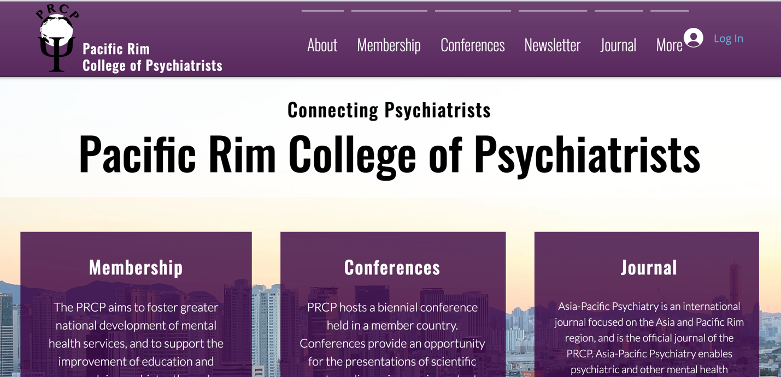

Alan Teo, M.D., M.S.
Associate Professor, Oregon Health & Science University
Core Investigator, Center to Improve Veteran Involvement in Care

9. Message from our new member Bao-Liang Zhong

It is my great honor to become the fellow of the PRCP. I am Associate Professor working in Affiliated Wuhan Mental Health Center, Tongji Mecial College of Huazhong University of Science and Technology. I obtained my Bachelor degree of Medicine in Peking University Health Science Center in 2006 and PhD degree of Medical Sciences in the Chinese University of Hong Kong in 2014. My major research interests include mood disorders, geriatric psychiatry, and mental health services.
The ongoing COVID-19 pandemic has resulted in unprecedented mental health crisis, underscoring the need for a strengthened collaboration of international communities to address the mental health challenges during the pandemic. For this reason, the PRCP provides a valuable platform to mental health workers in Asia-Pacific region to cooperate and share their experiences in combating COVID-19. Wuhan Mental Health Center was the only designated hospital for COVID-19 infected patients with mental disorders in China. During this difficult period, more than 300 infected psychiatric patients were treated in our hospital and psychological crisis intervention services were offered to tens of thousands of COVID patients and quarantined residents. Recently, our hospital has developed a municipality-wide psychosocial services program to provide mental health rehabilitation services to COVID-19 survivors and other subpopulations in need. As a new member of the PRCP, I would be happy to share our experiences with any colleagues who are interested in this area.

Bao-Liang Zhong, MD, PhD
Associate Professor in Psychiatry, Affiliated Wuhan Mental Health Center, Tongji Medical College of Huazhong University of Science & Technology

10. Coronavirus Covid-19 – Public Health Response

The coronavirus epidemic will be a major challenge for Australia. Without intense public health interventions this illness is likely to take thousands of lives across Australia. No Australian will be untouched by this virus. It is clear that unless the epidemic can be contained or the rate of infection can be slowed dramatically the hospital and health system will be overwhelmed.

Spread of this infection has gone from imported cases from overseas to now ‘community spread’. Community spread means that people are contracting the virus from other local individuals with no direct contact to overseas cases. This means that anyone can be infected with the virus and can infect others. As it is known that individuals infected with the virus but not showing any symptoms can shed virus particles and infect others, this means that citizens must now consider all other people as potential sources of infection. This includes brothers and sisters, mothers and fathers, children, other family members, friends, and workmates as well as strangers.

This situation makes the use of physical and social distancing and hygiene methods absolutely critical in all contacts with others. The careful practice of hand washing, avoiding handshaking and other physical contacts with others, maintaining a safe distance from others, using a mask, practicing appropriate coughing and sneezing etiquette, avoiding crowds and gatherings of any size, holding any necessary meetings outside or using teleconferencing, frequent disinfecting of touched surfaces, working from home, limited food handling are but some of the necessary methods needed to avoid the individual-to-individual spread of the virus. All members of the public must apply these interventions, with as much intensity as health professionals use them.

We suggest all members of the public use facemasks for three reasons. First, a mask will make it less likely a person with respiratory symptoms (cough, sneeze) will pass on infection; second, masks do reduce the chance of a healthy person getting infected and they inhibit individuals touching their face; and third, wearing a mask show solidarity with all in the community that we are trying to comply with distancing and hygiene advice. It is imperative that governments immediately provide all needed personal protective equipment for health personnel and also provide masks for the general population.

Individuals infected with the virus (either confirmed by test or suspected) should be isolated so they cannot infect the public. People with mild cases of the condition have been sent home to ‘self-isolate’. However, we think that is not good enough. These individuals must go to a government-provided secure accommodation location until they have recovered and are testing negative for the virus. Individuals with more severe illness should be isolated in a hospital given over to the care of coronavirus patients. These would be hospitals with the most intensive care beds and operating theatres (as they can be converted to intensive care areas). Contacts of these cases should be quarantined in government-provided secure accommodation until they have passed through the incubation period and testing negative for the virus.

Countries in Asia that have adopted these methods have been able to get control of this epidemic. It goes without saying that extensive and repeated testing for coronavirus cases is essential for this approach. Australia must lift its testing capacity immediately for all individuals who are unwell irrespective of recent overseas travel or contact with confirmed cases with tests that have a high level of accuracy.

In addition, to prevent virus spread, governments must close down all ways citizens can interact directly with each other in order to stop the infection from spreading. Apart from emergency services and medical, pharmaceutical and essential services (including supermarkets and water, power, garbage, and sewerage utilities), all other businesses, universities, sporting fixtures, clubs, bars, cafes, restaurants, churches, and all other places where people congregate will need to be closed. Activity will need to move online as much as possible. Individuals should not meet or congregate with others.

Closing schools is a difficult decision. Children sent home would need to be looked after. Parents working from home or out of work because of business closures would be able to provide this supervision. This task should not fall on grandparents in this situation because older members of our community are much more vulnerable to the effects of coronavirus. A special case needs to be made for the children of health professionals if we want these individuals to continue to care for the sick. For example, one or more closed schools could be used to provide supervision of the children of healthcare workers who agree. The care of these children could be managed by stood down teachers who want to work. On balance we believe pre-emptive closure of schools (before students or teachers test positive for the virus) is the most effective strategy of reducing virus spread.

The aim of all these steps is to suppress the epidemic to quickly get it under control. This is more ambitious than a mitigation strategy that tries to reduce the peak of the epidemic and spread it out longer. Mitigation is unlikely to protect the health system from being overwhelmed by very sick patients with coronavirus. Suppression methods apply very severe restrictions on individuals and business and society in order to reduce the transmission rate of the virus. The transmission rate is the number of people an infected person will infect on average. At the beginning of an epidemic in an unprepared country (like Australia) the transmission rate is that one infected person will pass the infection on to two to three others.

Without any interventions the rise of the infected cases becomes exponential. This is what was happening in Australia at the moment. If the transmission rate is above one the epidemic takes off. If it can be lowered to below one the epidemic dies down. The goal of the suppression strategy is to get the transmission rate to as close to zero as soon as possible. New Zealand is adopting this approach. This country hopes to eliminate the virus.

It is unclear for how long the application of intense suppression methods is needed, but overseas experience suggests between one to three months. After this, a gradual loosening of restrictions might be possible but the transmission rate must be kept under one for the epidemic to be controlled (references 1 and 2).

The good news is that this is possible. A combination of each individual citizen applying physical and social distancing and painstaking hygiene practices, as well as extensive health department testing and isolation of cases and contacts, and government closing down citizen physical interaction can be very effective. This approach was used to suppress the epidemic in Wuhan, China and is the method used to contain the epidemic successfully in Taiwan and some other Asian countriesIt is now the model adopted by New Zealand.

Suppression of the epidemic gives us time; time to identify effective treatments, and time to develop an effective vaccine. There is no reason that suppression cannot be implemented in Australia. It will challenge our social cohesion and require mutual support between all our citizens. And it requires Australian governments to trust that the Australian people can respond to the challenge and the impositions involved in order to reduce the magnitude of the disaster that otherwise would rapidly overtake us.

Prof Philip Morris AM
MBBS, BSc med, PhD, FRANZCP, FAChAM (RACP), DABPN
Distinguished Fellow PRCP

References
1. Coronavirus: The Hammer and the Dance
What the Next 18 Months Can Look Like, if Leaders Buy Us Time
Thomas Pueyo
20 March 2020
2. COVID-19: Imperial researchers model likely impact of public health measures
Dr Sabine l van Elsland, Ryan O’Hare
17 March 2020

11. List of PRCP Office Bearers and Board Directors

President |  | Board of Directors
Mian Yoon Chong | (Taiwan) | Itsuo Asai | (Japan)
President Elect |  | Susanna Every-Palmer | (New Zealand)
Chee Hong Ng | (Australia) | Julian Freidin | (Australia)
Vice President |  | Soma Ganesan | (Canada)
Tao Li | (China) | Susan Shur-Fen Gau | (Taiwan)
Yong Chon Park | (Korea) | Helen Herrman | (Australia)
Edmond Pi | (USA) | Narei Hong | (Korea)
Treasurer |  | Hong Ma | (China)
Philip Morris | (Australia) | Hiram Mok | (Canada)
Secretary General |  | Shinji Shimodera | (Japan)
Tsuyoshi Akiyama | (Japan) | Alan Teo | (USA)
Past President |  | Nor Zuraida Zainal | (Malaysia)
Pichet Udomratn | (Thailand) | Kang Seob Oh | (Korea)
 |  | Tin Oo | (Myanmar)
 |  | Andi Tanra | (Indonesia)
 |  | Samuel Law | (Canada)

12. Application for membership

APPLICATION FORM FOR MEMBERSHIP OF
THE PACIFIC RIM COLLEGE OF PSYCHIATRISTS
DATE
TITLE
FIRST NAME
LAST NAME
DATE OF BIRTH
COUNTRY: GENDER:
CURRENT POSITION
MAILING ADDRESS
HOME PHONE : FAX:
OFFICE PHONE
E-MAIL
SPECIALIST BOARD: DATE RECEIVED:
􀂉 PSYCHIATRY
􀂉 NEUROLOGY
􀂉 OTHER (PLEASE SPECIFY)
CURRENT INTERESTS:
􀂉 CLINICAL
􀂉 TEACHING
􀂉 RESEARCH
􀂉 CROSS CULTURAL
SPECIALIST TRAINING:
QUALIFICATIONS:
YEARS WORKED AS PSYCHIATRISTS:
MEMBERSHIP OF NATIONAL ASSOCIATIONS:
INTERNATIONAL ACTIVITIES
Please return this form with your CV and one passport photo to the PRCP Secretariat located at:
Department of Neuropsychiatry, NTT MEDICAL CENTER TOKYO
5-9-22 Higashi-gotanda, Shinagawa-ku, Tokyo 141-8625, JAPAN
Phone: + 81 3 3448 6508 Facsimile: + 81 3 3448 6507
E mail: info@prcp.org
*PRCP recognizes World Bank Economic Categories. Please see the PRCP website for details: www.prcp.org/members.html
